**NIFTY**

— The Nifty meaning is a derivation from the mix of two words, i.e. “National Stock Exchange” and “fifty”. It is an abbreviation of the National Stock Exchange Fifty. It is a collection of top performing 50 equity stocks that are actively trading in the index. However, 51 stocks are currently trading on Nifty. Hence, Nifty is also known as Nifty50 or CNX Nifty.

Nifty is a popular stock index.

**INDEX**?

— A stock index is a measurement of the changes that take place in the stock market. It measures price movement and market performance. For creating an index, one has to group some stocks from the list of stocks with similar characteristics. This grouping of stocks can be on the type of industry, total market capitalization or the size of the company.

To calculate the value of the stock market index, one can use the values of the underlying group of stocks. Any change in the value of underlying stock also leads to a change in the stock index value. If the price of most of the stocks rises, the index will again rise and vice-versa.

Thus, an index is indicative of changes in the market.

**SENSEX?**

— Sensex, in simple words, is the combined value of stocks of 30 specific companies listed on Bombay stock exchange (BSE).

**Sensex= (total free float market capitalization/ Base market capitalization) * Base index value.**

The BSE SENSEX is a free-float market-weighted stock market index of 30 well-established and financially sound companies listed on the Bombay Stock Exchange.

**BULL Vs BEAR?**

-– A bull market occurs when the economy is expanding and the stock market is gaining value, while a bear market is in effect when the economy is shrinking.

A Bull [market](https://www.fool.com/investing/how-to-invest/bull-market/) takes effect when stock prices have broadly increased by at least 20% since the last market downturn. Bull market conditions can last for decades, and many successful investors have bet very wrongly by trying to predict the end of a bull market.

A B[ear market](https://www.fool.com/investing/how-to-invest/bear-market/) is defined as starting when stock prices broadly decline by 20% and keep trending lower. Bear markets are characterized by people losing their jobs, gross domestic product (GDP) declining, and the stock market losing significant value. Bear markets almost never last as long as bull markets and can create buying opportunities for investors.

**NSE** and **BSE**?

— Markets

**GRAPHICAL LASSO?**

Excercise : Retrieve daily stock price from Yahoo Finance data using Python

All NSE information is available on NSE website.

NSE or National stock exchange has got many sectors:

1. [NIFTY Auto Index](https://www.niftyindices.com/indices/equity/sectoral-indices/nifty-auto)
2. [NIFTY Bank Index](https://www.niftyindices.com/indices/equity/sectoral-indices/nifty-bank)
3. [NIFTY Financial Services Index](https://www.niftyindices.com/indices/equity/sectoral-indices/nifty-financial-services)
4. [NIFTY Financial Services 25/50 Index](https://www.niftyindices.com/indices/equity/sectoral-indices/nifty-financial-services-25-50-index)
5. [NIFTY Financial Services Ex-Bank index](https://www.niftyindices.com/indices/equity/sectoral-indices/nifty-financial-services-ex-bank)
6. [NIFTY FMCG Index](https://www.niftyindices.com/indices/equity/sectoral-indices/nifty-fmcg)
7. [NIFTY Healthcare Index](https://www.niftyindices.com/indices/equity/sectoral-indices/nifty-healthcare-index)
8. [NIFTY IT Index](https://www.niftyindices.com/indices/equity/sectoral-indices/nifty-it)
9. [NIFTY Media Index](https://www.niftyindices.com/indices/equity/sectoral-indices/nifty-media)
10. [NIFTY Metal Index](https://www.niftyindices.com/indices/equity/sectoral-indices/nifty-metal)
11. [NIFTY Pharma Index](https://www.niftyindices.com/indices/equity/sectoral-indices/nifty-pharma)
12. [NIFTY Private Bank Index](https://www.niftyindices.com/indices/equity/sectoral-indices/nifty-private-bank)
13. [NIFTY PSU Bank Index](https://www.niftyindices.com/indices/equity/sectoral-indices/nifty-psu-bank)
14. [NIFTY Realty Index](https://www.niftyindices.com/indices/equity/sectoral-indices/nifty-realty)
15. [NIFTY Consumer Durables Index](https://www.niftyindices.com/indices/equity/sectoral-indices/nifty-consumer-durables-index)
16. [NIFTY Oil and Gas Index](https://www.niftyindices.com/indices/equity/sectoral-indices/nifty-oil-and-gas-index)
17. In each sector are a list of companies which are most influential in that sector. The particular sector also has an index.
18. The companies therefore have a weightage based on their importance. Normally, the top 10 highest weighted or important companies contribute about 90% index of that particular sector. The remaining 10% are contributed by other small companies.

* Higher contribution means more significant that stock is to that sector.
* Two companies may face the same amount of loss, but based on their importance or contribution, the rise/fall in the sector is decided,i.e, one company makes more influence and the other may influence less, depending on its contribution or index.

1. The sectors are also associated with an index. This index when it increases means that sector is doing well and vice versa.
2. Lets say, in the auto sector, Maruti Suzuki India Ltd contributes the highest importance, then we can say that, when the contribution or stock price of Maruti Suzuki goes down, then there is a high chance that the auto sector will also go down.

Portfolio optimization in finance is the technique of creating a portfolio of assets, for which your investment has the maximum return and minimum risk.

**What does Portfolio Optimization Mean?**

Portfolio optimization is the process of creating a portfolio of assets, for which your investment has the maximum return and minimum risk.

**What does a Portfolio Mean?**

An investor's portfolio basically is his/her investment in different kinds of assets from different companies.

For example, if you have investments in 3 companies, say, X, Y, and Z, then these 3 companies make up your investment portfolio.

But how do you invest in a company? You do so by purchasing assets of that company.

**What are Assets, Returns, and Risk?**

Assets are of various kinds. An asset is what you would purchase if you want to invest in a company.

These include, but are not limited to:

1. Bonds

2. Stocks

3. Cash

4. Real Estate

Usually when you build a portfolio. It is advisable to diversify your assets, or purchase different kinds of assets from different companies. For all assets, you will get a profit after a specified perlod of time. However, the profit may not be the same for each investment you make.

**This profit is what we call returns.**

For example, you will get returns from stocks when it's market value goes up and similarly you will get returns from cash in the form of interest.

But what if the company whose stocks you have purchased goes bankrupt?

This will lead to its stocks crashing in the share market and instead of gaining profits, you will also lose your capital investment.

**This is what is called risk of investment.**

Another aspect of risk is the fluctuations in the asset value. For certain assets, its value is highly volatile, that is, the value increases when the market goes up, and drops accordingly. Whereas certain other assets, like bonds and certain steady stocks, are relatively more resistant to market conditions, but may give lesser returns compared to high risk ones.

A good portfolio is one which gives us maximum return on our investment for minimum risk, as discussed earlier.

The next question is, how do we decide out of an infinite possible combination for portfolios, the one which is optimum?

**Modern Portfolio Theory**

Modern Portfolio Theory, or also known as mean-variance analysis is a mathematical process which allows the user to maximize returns for a given risk level. It was formulated by H. Markowitz and while it is not the only optimization technique known, it is the most widely used.

MPT assumes that all investors are risk-averse, i.e, if there is a choice between low risk and high risk portfolios with the same returns, an investor will choose

one with the low risk.

So. what is the MPT all about?

MPT encourages diversification of assets. It says that a high variance asset A if combined with diverse assets B and C, where A, B and C have little to no

correlation, can give us a portfolio with low variance on returns.

This is the crux of the Modern Portfolio Theory.

**What is an Efficient Frontier?**

We know every asset In a portfolio has Its own rate of expected returns and risks. It Is possible to create multiple combinations of assets that can provide high returns for a predefined risk level,

Likewise, there can be multiple portfolios that give lowest risk for a pre-defined expected return.

Efficient frontier is a graph with returns' on the Y-axis and volatility on the X-axis. It shows the set of optimal portfolios that offer the highest expected return for a given risk level or the lowest risk for a given level of expected return.

Portfolios that lie outside the efficient frontier are sub-optimal because they do not provide either enough return for the level of risk or have a higher risk for the

defined rate of return.

**Note** : Usually, high returns are subjected to high risk as well.

Therefore, *Return is directly proportional to risk.*

**Note: Time series plays an important role here:**

Why?

A time series is a particular variable subjected to time. Ex- Rainfall data, Sunspots data.

And then a pattern can be derived and used for forecasting.

Likewise, here the stock prices fluctuates with time.

How do we interpret it or where is it given?

– Open Price : The price at which the stock was offered at when the market opened.

– Close Price : The price at which the stock was offered at when the market closed.

– High Price : The highest price at which the stock rose.

– Low Price : The lowest price at which the stock fell.

– Volume : Volume of stock.

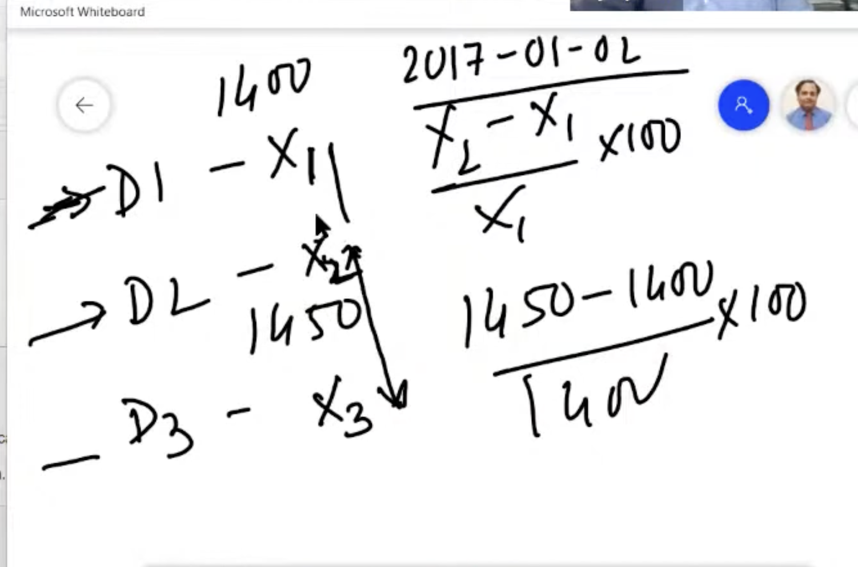

**Note**: When calculating the Return, a day is compared with its previous day.

Let’s say;

For Day1: Price was X1 and

For Day 2: Price was X2

**then, Return = (X2 - X1)/X1**

And if Price for Day 3 was X3, then

**Return = (X3 - X2)/X2**

Now,

**How do we measure the Risk?**

– So, we know that a stock price fluctuates, and depending on the fluctuations, we decide whether it is highly volatile or less volatile. This is where we get the idea of Risk.

We can get the avg of the fluctuations in price. Any point above it is highly volatile and vice versa.

**How is the Risk identified?**

– We first take into consideration the variance, to check how much it varies. And then we can compute the standard deviation.i.e., square of the variance.

The catch here is to consider yearly volatility and not daily volatility. This is because daily volatility may not show considerable change.

We also need to take into account the yearly working days.

**Calculating Volatility,**

1. We take the daily return values.
2. Convert into its logarithmic form just to reduce the values even more to decrease the volatility.
3. Then we take the STDEV of the daily logarithmic return values.
4. We then multiply that with sqrt(250) to take into account the yearly working days.
5. So using this, we can see which stock is more volatile, hence more risky.

**Note :** A highly risky stock doesn't necessarily mean its bad. That depends on the Returns.

**Now, we know that a portfolio is made of many assets. But do we know the correlation between them?**

– When we find that two assets are highly correlated, we can make their weightages accordingly. That means, we can make one High and the other low. This is because if too much is invested together, and both suffer loss, the total loss will be very high. This is called lacking diversity.

As we want to look for diversity in the portfolio so that if a particular stock falls, others will make sure to balance that and not incur a massive loss.

Now let’s say we have 5 assets and we invest equally in all, and try to find the weighted return, we see the return to be low.

Likewise, even if we invest randomly, the return is not really high.

**Efficient Frontier:** Graph of Returns Vs Volatility; where **Volatility is X-axis** and **Return is y-axis.**

To get the best return from a portfolio, we can make multiple or hundreds of portfolios of different combinations of weights, keeping in mind that the sum of weights should be 1.

**How to read the Efficient Frontier?**

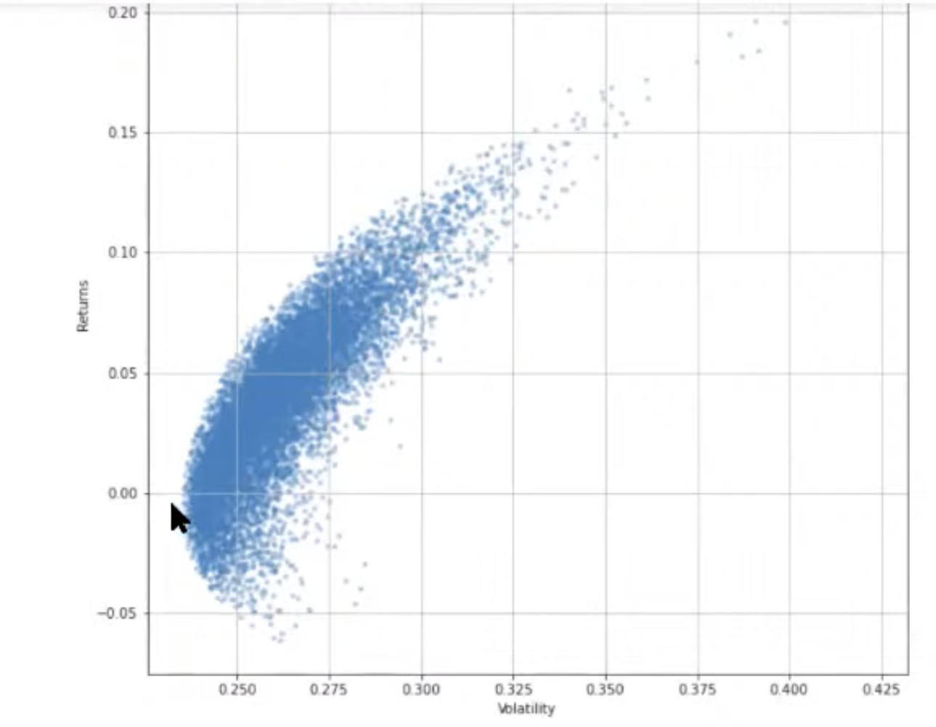

Each point on the line (left edge) represents an optimal portfolio of stocks that maximizes the returns for any given level of risk.

The points (portfolios) In the Interior are sub-optimal for a given risk level. For every interior point, there Is another that offers higher returns for the same risk.

On this graph, you can also see the combination of weights that will give you all possible combinations:

1. Minimum volatility (left most point)

2. Maximum returns (top most point)

And everything In between.

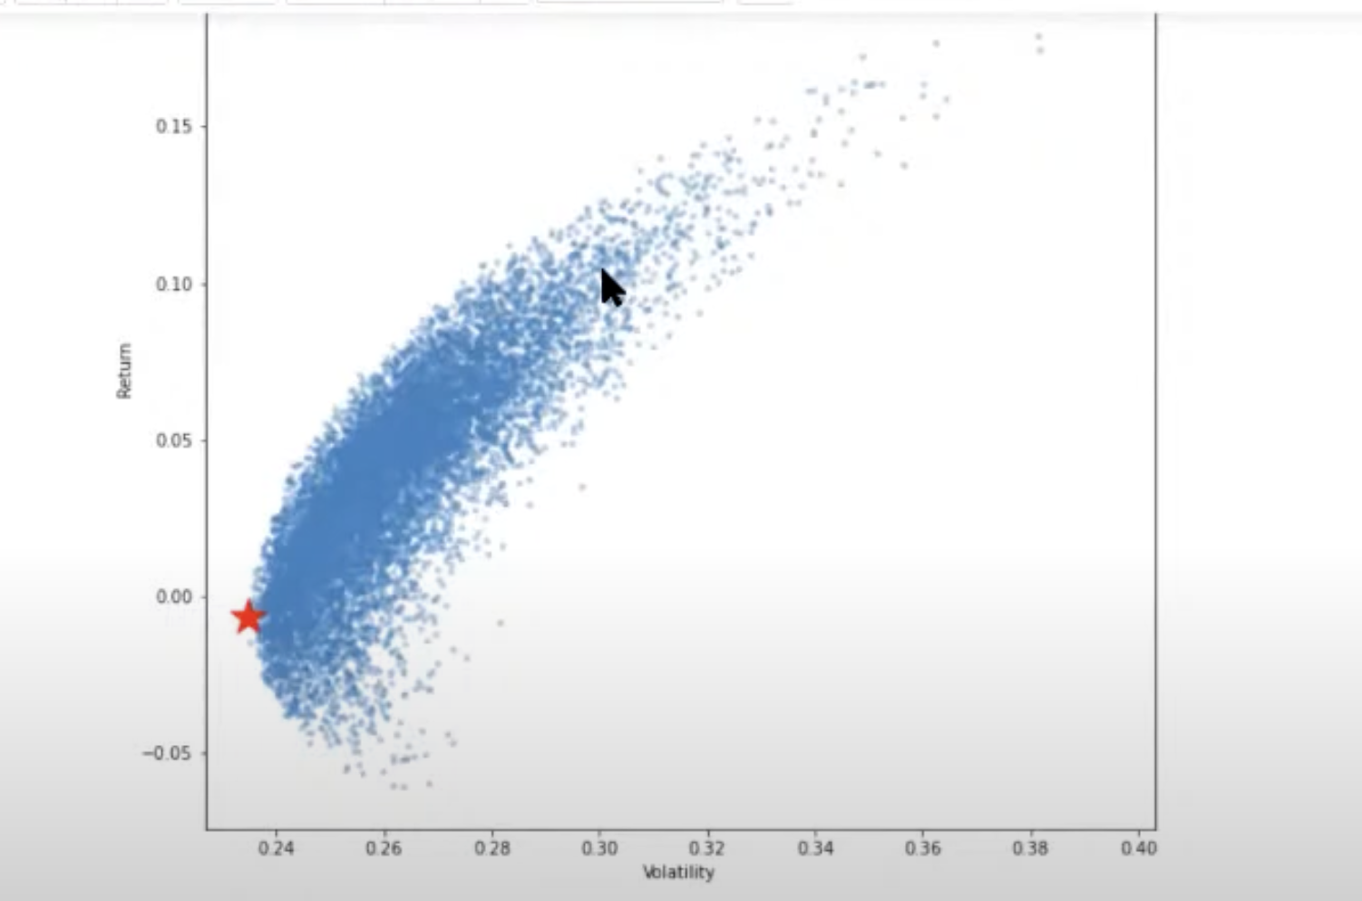

The red star denotes the most efficient portfolio with minimum volatility.

It is worthwhile to note that any point to the right of the efficient frontier boundary is a sup-optimal portfolio.

We found the portfolio with minimum volatility, but you will notice that the return on this portfolio is pretty low. Any sensible investor wants to maximize his return, even if it is a tradeoff with some level of risk.

The question arises that how do we find this optimal risky portfolio and finally optimize our portfolio to the maximum?

This is done by using a parameter called the **Sharpe Ratio.**

**Sharpe Ratio**

This is where the **magic** happens. This is where we optimize.

– We travel along the boundary line and look for the best portfolio. But traveling along the boundary will also increase the volatility. So we need to find the optimum point.

**HOW?**

– We move along the boundary until The Rate of increase of Return is greater than the Rate of increase of Volatility.

**This is where Sharpe Ratio comes into the picture.**

The ratio is the average return earned in excess of the risk-free rate per unit of volatility or total risk. Volatility is a measure of the price fluctuations of an asset or portfolio.

The risk-free rate of return is the return on an investment with zero risk, meaning It's the return investors could expect for taking no risk.

The optimal risky portfolio is the one with the highest Sharpe ratio.

